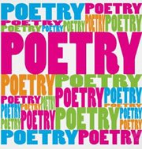

**ENiGMA NATIONAL POETRY WEEK**

***POSTIIVE POETRY***

**21st – 25th May, 2018**

**BRIEF FOR LEARNERS ENTERING THE NATIONAL COMPETITION:**

You can enter a piece of work under any the following headings or themes:

**Love Truth Happiness Freedom Fear**

**Friendship Holidays Jealousy Travel Dreams**

**Forgiveness War Education Envy Nature**

**New beginnings Sport Hope Health and Happiness**

Under the following categories (please make your category clear on work submitted).

* Creative writing (maximum 500 words)
* Mini saga (text of exactly 50 words)
* A Tweet (maximum 140 characters)
* A rap
* Illustrated comic
* Poetry

Illustrations to support any of the above are encouraged.

Deadline date for entries to the National Competition **– 29th June, 2018**

**Prizes will include: –**

* *A certificate of achievement for all entries*
* *Winning poems and those highly commended will be made in to a Positive Poetry booklet*
* *The winning poem will be published in Inside Times*
* *A range of highly recommended Diffusion books for those entries that are highly commended.*